Team:

Chris Hitte

Gene Zhang

Brandon Boylan-Peck

Title: Settlers of Catan

Project Summary

For our semester project we will be implementing the popular board game, Settlers of Catan. At the end of the semester, we would like to have a Pass-and-Play version of Settlers of Catan which supports all components of the game (trading, placing settlements, earning resources, etc.) and enforces all rules. We will be focusing on the mechanics of the game over the look and feel. As such not all mechanics may be represented in the UI at the end of the project, but they will all be implemented properly.

Project Requirements

**Business Requirements:**

N/A

|  |  |  |  |  |
| --- | --- | --- | --- | --- |
| **User Requirements** | | | | |
| **ID** | **Description** | **Actor** | **Topic** | **Priority** |
| US-01 | As a Player, I want to start a new game with the option of 3 players and 4 players. | Player | Game Management | High |
| US-02 | As a Player, I want to load a previously saved game and resume playing. | Player | Game Management | Low |
| US-03 | As a Player, I want to set up my initial pieces at the start of the game. | Player | Setup | High |
| US-04 | As the Current Player, I want to be able to start my turn. | Current Player | Rolling | High |
| US-05 | As the Current Player, if I roll a 7 I want to be able to place the Robber and steal a card from a target Player. | Current Player, Other Player | Rolling | Low |
| US-06 | As a Player, if a 7 is rolled and I have 7 or more cards in my had, I need to be able to discard the proper number of cards. | Player | Rolling | Low |
| US-07 | As the Current Player I want to be able to trade Resource Cards with other Players | Current Player, Other Players | Trading | Med |
| US-08 | As the Current Player I want to be able to trade Resources with the Bank. | Current Player | Bank | Med |
| US-09 | As the Current Player I want to be able to purchase structures. | Current Player | Purchasing | High |
| US-10 | As the Current Player I want to be able to purchase Development Cards | Current Player | Purchasing | Med |
| US-11 | As the Current Player I need to be able to place structures I have purchased. | Current Player | Building | High |
| US-12 | As the Current Player I need to be able to play Development Cards I have purchased. | Current Player | Development Cards | Med |

|  |  |  |  |  |
| --- | --- | --- | --- | --- |
| **Functional Requirements** | | | | |
| **ID** | **Description** | **Actor** | **Topic** | **Priority** |
| FR-01 | The System will allow all Players to set up their pieces in order. | System, Players | Setup | High |
| FR-02 | The System will begin each turn by rolling the dice. | System | Rolling | High |
| FR-03 | The System will distribute the correct Resources to the correct Players based on the value of the roll. | System, Players | Resources | High |
| FR-04 | When a Player is selected to be robbed, the System will randomly move one Resource from the target Player’s inventory to the Current Player’s inventory. | System, Current Player, Other Player | Robber | Low |
| FR-05 | The System validates that the Current Player has the necessary Resources before any purchase is completed. | System, Current Player | Purchasing | High |
| FR-06 | The System validates that a selected location is legal before the Current User builds a structure on it. | System, Current Player | Building | High |
| FR-07 | The System does not allow the Current Player to play a Development Card in the same turn that it was purchased. | System, Current Player | Development Cards | Med |
| FR-08 | The System will save all game state to the database when a game is exited. | System | Game Management | Low |
| FR-09 | The System will reconstruct all game state when a Player loads a previously saved game. | System, Player | Game Management | Low |

|  |  |  |  |  |
| --- | --- | --- | --- | --- |
| **Non-Functional Requirements** | | | | |
| **ID** | **Description** | **Actor** | **Topic** | **Priority** |
| NFR-01 | The System should run smoothly enough and quickly enough to support fun game play. | System | Performance | High |
| NFR-02 | All game data such as Resources and Victory Points should be calculated and stored accurately. | System | Reliability | High |

Use Cases

* Actors:
  + Player (general case)
  + Current Player
  + Other Player 1
  + Other Player 2
  + Other Player 3
  + System
* Use Case Overview













* Use Case Documents

|  |  |
| --- | --- |
| **Use Case ID:** | UC-01 |
| **Use Case Name:** | Start New Game |
| **Description:** | Player begins new game |
| **Actors:** | Player |
| **Pre-conditions:** |  |
| **Post-conditions:** | A new game has been created and started. |
| **Frequency:** | Once per game period |
| **Flow of Events:** | |  |  |  | | --- | --- | --- | |  | **Actor Action** | **System Response** | | 1 | Player selects a 3 or 4 player game | System creates a new game for 3 or 4 players | |
| **Variations:** |  |
| **Exceptions:** |  |
| **Developer Notes:** |  |

|  |  |  |
| --- | --- | --- |
| **Use Case ID:** | UC-02 | |
| **Use Case Name:** | Setup Initial Pieces | |
| **Description:** | At the beginning of the game each Player takes turns placing a Road and a Settlement until each player has two Roads and two Settlements on the Board | |
| **Actors:** | Current Player, Other Players |
| **Pre-conditions:** | Game has begun and is in the Setup Phase |
| **Post-conditions:** | Each Player has two Settlements and two Roads on the Board |
| **Frequency:** | Once at the beginning of the game |
| **Flow of Events:** | |  |  |  | | --- | --- | --- | |  | **Actor Action** | **System Response** | | 1 | Player 1 selects a location for a Settlement and a Road and confirms placement | System verifies the selected location and updates the Board state | | 2 | Player 2 selects a location for a Settlement and a Road and confirms placement | System verifies the selected location and updates the Board state | | 3 | Player 3 selects a location for a Settlement and a Road and confirms placement | System verifies the selected location and updates the Board state | | 4 | Player 4 selects a location for two Settlements and two Roads and confirms placement | System verifies the selected locations and updates the Board state | | 5 | Player 3 selects a location for a Settlement and a Road and confirms placement | System verifies the selected location and updates the Board state | | 6 | Player 2 selects a location for a Settlement and a Road and confirms placement | System verifies the selected location and updates the Board state | | 7 | Player 1 selects a location for a Settlement and a Road and confirms placement | System verifies the selected location and updates the Board state | |
| **Variations:** |  |
| **Exceptions:** | 1-7. Invalid location selected for Settlement or Road |
| **Developer Notes:** | If there are only 3 Players playing then the Flow will proceed as normal until it is Player 3’s turn. Player 3 will put down both of his/her Settlements and Roads. After Player 3 is finished, then Player 2 goes, followed by Player 1. |

|  |  |
| --- | --- |
| **Use Case ID:** | UC-03 |
| **Use Case Name:** | Load Saved Game |
| **Description:** | Player loads a saved game |
| **Actors:** | Player |
| **Pre-conditions:** | There exists a previously saved game on the system |
| **Post-conditions:** | The game is resumed. |
| **Frequency:** | Once per game period |
| **Flow of Events:** | |  |  |  | | --- | --- | --- | |  | **Actor Action** | **System Response** | | 1 | Player selects a Saved Game form the list of games on the Main Menu | System loads the Saved Game data from the database and reinitializes the game | |
| **Variations:** |  |
| **Exceptions:** |  |
| **Developer Notes:** |  |

|  |  |
| --- | --- |
| **Use Case ID:** | UC-04 |
| **Use Case Name:** | Start Turn |
| **Description:** | Current Player officially begins turn |
| **Actors:** | Current Player, Players |
| **Pre-conditions:** | Previous Player has ended his/her turn |
| **Post-conditions:** | Dice are rolled and resources are distributed, or robber is placed |
| **Frequency:** | Once per turn |
| **Flow of Events:** | |  |  |  | | --- | --- | --- | |  | **Actor Action** | **System Response** | | 1 | User clicks “Start Turn” button | System rolls a 7 | | 2 | Players select Resource Cards to discard and confirms their selection | System validates that the appropriate number of Resource Cards have been discarded | | 3 | Current Player picks a hex to move the Robber to | System validates the choice (must be a different tile than where the Robber began) | | 4 | Current Player selects a player who owns a settlement on the selected hex to give up a card | System validates Player selection; randomly picks a Resource Card from that Player’s cards and gives it to the Current Player | |
| **Variations:** | The system does not roll a 7 and distributes resources normally. |
| **Exceptions:** |  |
| **Developer Notes:** |  |

|  |  |
| --- | --- |
| **Use Case ID:** | UC-05 |
| **Use Case Name:** | Trade Resources w/ Players |
| **Description:** | Current Player can open a Trade Menu to trade with other players |
| **Actors:** | Current Player, Other Players |
| **Pre-conditions:** | Current Player has started his/her turn |
| **Post-conditions:** | Trade Menu opens |
| **Frequency:** | 0..\* times per turn |
| **Flow of Events:** | |  |  |  | | --- | --- | --- | |  | **Actor Action** | **System Response** | | 1 | Current Player clicks the ‘Trade’ button | System opens the Trading Menu | |
| **Variations:** |  |
| **Exceptions:** |  |
| **Developer Notes:** |  |

|  |  |
| --- | --- |
| **Use Case ID:** | UC-06 |
| **Use Case Name:** | Trade Resources w/ Bank |
| **Description:** | Current Player can open a menu to trade Resources with the Bank |
| **Actors:** | Current Player |
| **Pre-conditions:** | Current Player has started his/her turn |
| **Post-conditions:** | Exchange Menu opens |
| **Frequency:** | 0..\* times per turn |
| **Flow of Events:** | |  |  |  | | --- | --- | --- | |  | **Actor Action** | **System Response** | | 1 | Current Player clicks the ‘Exchange’ button | System opens the Trade with Bank Menu | |
| **Variations:** |  |
| **Exceptions:** |  |
| **Developer Notes:** |  |

|  |  |
| --- | --- |
| **Use Case ID:** | UC-07 |
| **Use Case Name:** | Make Offer |
| **Description:** | Current Player or any Player can designate Resource Cards they are willing to Exchange or Trade |
| **Actors:** | Players |
| **Pre-conditions:** | Player has opened the Exchange or the Trade menu |
| **Post-conditions:** | Some combination of Resources is selected |
| **Frequency:** | 0..\* times per turn |
| **Flow of Events:** | |  |  |  | | --- | --- | --- | |  | **Actor Action** | **System Response** | | 1 | Player designates a combination and quantity of Resources to exchange or trade |  | |
| **Variations:** |  |
| **Exceptions:** |  |
| **Developer Notes:** |  |

|  |  |
| --- | --- |
| **Use Case ID:** | UC-08 |
| **Use Case Name:** | Finish Trade |
| **Description:** | Current Player completes the Trade |
| **Actors:** | Current Player |
| **Pre-conditions:** | Current Player has opened either the Exchange or the Trade menu and all necessary Players have made their offer |
| **Post-conditions:** | Resource Cards are Exchanged/Traded and all relevant Players’ inventories are updated |
| **Frequency:** |  |
| **Flow of Events:** | |  |  |  | | --- | --- | --- | |  | **Actor Action** | **System Response** | | 1 | Current Player clicks the ‘Confirm’ button | System validates that the Trade is legal. System updates each relevant Player’s inventory. Menu closes. | |
| **Variations:** | 1. Current Player cancels trade |
| **Exceptions:** | 1. Trade is illegal |
| **Developer Notes:** |  |

|  |  |
| --- | --- |
| **Use Case ID:** | UC-09 |
| **Use Case Name:** | Purchase Settlement |
| **Description:** | Current Player can purchase a Settlement |
| **Actors:** | Current Player |
| **Pre-conditions:** | Current Player has started his/her turn |
| **Post-conditions:** | Current Player exchanges Resource Cards for a Settlement |
| **Frequency:** | 0..\* times per turn |
| **Flow of Events:** | |  |  |  | | --- | --- | --- | |  | **Actor Action** | **System Response** | | 1 | Current Player clicks the ‘Purchase Settlement’ Button | System validates the purchase and removes the required Resources from the Current Player’s Inventory. System adds the Settlement to the Current Player’s inventory. System switches to the Build Settlement state. | |
| **Variations:** |  |
| **Exceptions:** | 3. Current Player does not have required Resources |
| **Developer Notes:** |  |

|  |  |
| --- | --- |
| **Use Case ID:** | UC-10 |
| **Use Case Name:** | Purchase Road |
| **Description:** | Current Player can purchase a Road |
| **Actors:** | Current Player |
| **Pre-conditions:** | Current Player has started his/her turn |
| **Post-conditions:** | Current Player exchanges Resources for a Road |
| **Frequency:** | 0..\* times per turn |
| **Flow of Events:** | |  |  |  | | --- | --- | --- | |  | **Actor Action** | **System Response** | | 1 | Current Player clicks the ‘Purchase Road’ Button | System validates the purchase and removes the required Resources from the Current Player’s Inventory. System adds the Road to the Current Player’s inventory. System switches to the Build Road state. | |
| **Variations:** |  |
| **Exceptions:** | 3. Current Player does not have required Resources |
| **Developer Notes:** |  |

|  |  |
| --- | --- |
| **Use Case ID:** | UC-11 |
| **Use Case Name:** | Purchase City |
| **Description:** | Current Player can purchase a City |
| **Actors:** | Current Player |
| **Pre-conditions:** | Current Player has started his/her turn |
| **Post-conditions:** | Current Player exchanges Resources for a City |
| **Frequency:** | 0..\* times per turn |
| **Flow of Events:** | |  |  |  | | --- | --- | --- | |  | **Actor Action** | **System Response** | | 1 | Current Player clicks the ‘Purchase City’ Button | System validates the purchase and removes the required Resources from the Current Player’s Inventory. System adds the City to the Current Player’s inventory. System switches to the Build City state. | |
| **Variations:** |  |
| **Exceptions:** | 3. Current Player does not have required Resources |
| **Developer Notes:** |  |

|  |  |
| --- | --- |
| **Use Case ID:** | UC-12 |
| **Use Case Name:** | Purchase Development Card |
| **Description:** | Current Player can purchase a Development Card |
| **Actors:** | Current Player |
| **Pre-conditions:** | Current Player has started his/her turn |
| **Post-conditions:** | Current Player exchanges Resources for a Development Card |
| **Frequency:** | 0..\* times per turn |
| **Flow of Events:** | |  |  |  | | --- | --- | --- | |  | **Actor Action** | **System Response** | | 1 | Current Player clicks the ‘Purchase Development Card’ Button | System validates the purchase and removes the required Resources from the Current Player’s Inventory. System adds the Development Card to the Current Player’s inventory. | |
| **Variations:** |  |
| **Exceptions:** | 3. Current Player does not have required Resources |
| **Developer Notes:** |  |

|  |  |
| --- | --- |
| **Use Case ID:** | UC-13 |
| **Use Case Name:** | Place Road |
| **Description:** | Place a purchased Road on the Board |
| **Actors:** | Current Player |
| **Pre-conditions:** | Current Player has purchased a Road |
| **Post-conditions:** | The Road has been placed on the Board |
| **Frequency:** | 0..\* times per turn |
| **Flow of Events:** | |  |  |  | | --- | --- | --- | |  | **Actor Action** | **System Response** | | 1 | Current Player selects a location on the board and confirms placement | System validates that the location is an Edge connected to another Edge that also has a Road belonging to the Current Player. System adds the Road at this location. System returns to the Default state. | |
| **Variations:** |  |
| **Exceptions:** | 1. Invalid location selected |
| **Developer Notes:** |  |

|  |  |
| --- | --- |
| **Use Case ID:** | UC-14 |
| **Use Case Name:** | Place City |
| **Description:** | Place a purchased City on the Board |
| **Actors:** | Current Player |
| **Pre-conditions:** | Current Player has purchased a City |
| **Post-conditions:** | The City has been placed on the Board |
| **Frequency:** | 0..\* times per turn |
| **Flow of Events:** | |  |  |  | | --- | --- | --- | |  | **Actor Action** | **System Response** | | 1 | Current Player selects a location on the board and confirms placement | System validates that the location is a Corner that already contains a Settlement belonging to the Current Player. System adds the City at this location. System returns to the Default state. | |
| **Variations:** |  |
| **Exceptions:** | 1. Invalid location selected |
| **Developer Notes:** |  |

|  |  |
| --- | --- |
| **Use Case ID:** | UC-15 |
| **Use Case Name:** | Place Settlement |
| **Description:** | Place a purchased Settlement on the Board |
| **Actors:** | Current Player |
| **Pre-conditions:** | Current Player has purchased a Settlement |
| **Post-conditions:** | The Settlement has been placed on the Board |
| **Frequency:** | 0..\* times per turn |
| **Flow of Events:** | |  |  |  | | --- | --- | --- | |  | **Actor Action** | **System Response** | | 1 | Current Player selects a location on the board and confirms placement | System validates that the location is a Corner that does not belong to any player and that is not within 1 Edge of another Settlement. System adds the Settlement at this location. System returns to the Default state. | |
| **Variations:** |  |
| **Exceptions:** | 1. Invalid location selected |
| **Developer Notes:** |  |

|  |  |
| --- | --- |
| **Use Case ID:** | UC-16 |
| **Use Case Name:** | Play ‘Knight’ Card |
| **Description:** | Play a Knight card from the Current Player’s inventory |
| **Actors:** | Current Player, Other Player |
| **Pre-conditions:** | Current Player has a Knight card in his/her inventory |
| **Post-conditions:** | The Knight card is removed from the Current Player’s inventory, the Robber is moved, and a card is stolen from a selected Player if possible |
| **Frequency:** | 0..\* times per turn |
| **Flow of Events:** | |  |  |  | | --- | --- | --- | |  | **Actor Action** | **System Response** | | 1 | Current Player presses the ‘Play Knight Card’ Button | System validates that the Current Player has a Knight card in his/her inventory that was not purchased this turn. System enters the Play Knight state. | | 2 | Current Player selects a new Hex for the Robber | System validates that the new Hex is not the same as the previous Hex for the Robber. System returns a list of Other Players that share the new Hex. | | 3 | Current Player selects a Player to steal from | System places a random Resource in the Current Player’s inventory from the selected Player’s inventory. System enters the Default state. | |
| **Variations:** |  |
| **Exceptions:** | 1. No Knight card available; Invalid location selected |
| **Developer Notes:** |  |

|  |  |
| --- | --- |
| **Use Case ID:** | UC-17 |
| **Use Case Name:** | Play ‘Road Builder’ Card |
| **Description:** | Play a Road Builder card from the Current Player’s inventory |
| **Actors:** | Current Player |
| **Pre-conditions:** | Current Player has a Road Builder card in his/her inventory |
| **Post-conditions:** | The Road Builder card is removed from the Current Player’s inventory, the Current Player places 2 roads at valid locations on the Board |
| **Frequency:** | 0..\* times per turn |
| **Flow of Events:** | |  |  |  | | --- | --- | --- | |  | **Actor Action** | **System Response** | | 1 | Current Player presses the ‘Play Road Builder Card’ Button | System validates that the Current Player has a Road Builder card in his/her inventory that was not purchased this turn. System enters the Play Road Builder state. | | 2 | Current Player selects a location for his/her first Road | System validates that the location is an Edge connected to another Edge that also has a Road belonging to the Current Player. System adds the Road at this location. | | 3 | Current Player selects a location for his/her second Road | System validates that the location is an Edge connected to another Edge that also has a Road belonging to the Current Player. System adds the Road at this location. System returns to the Default state. | |
| **Variations:** |  |
| **Exceptions:** | 1. No Road Builder card available; Invalid location selected |
| **Developer Notes:** |  |

|  |  |
| --- | --- |
| **Use Case ID:** | UC-18 |
| **Use Case Name:** | Play ‘Monopoly’ Card |
| **Description:** | Play a Monopoly card from the Current Player’s inventory |
| **Actors:** | Current Player |
| **Pre-conditions:** | Current Player has a Monopoly card in his/her inventory |
| **Post-conditions:** | The Monopoly card is removed from the Current Player’s inventory, all Resources of the selected type are removed from the Other Player’s inventories and added to the Current Player’s inventory |
| **Frequency:** | 0..\* times per turn |
| **Flow of Events:** | |  |  |  | | --- | --- | --- | |  | **Actor Action** | **System Response** | | 1 | Current Player presses the ‘Play Monopoly Card’ Button | System validates that the Current Player has a Monopoly card in his/her inventory that was not purchased this turn. System enters the Play Monopoly state. | | 2 | Current Player selects a Resource type | All Resources of the selected type are removed from the Other Player’s inventories and added to the Current Player’s inventory by the System. | |
| **Variations:** |  |
| **Exceptions:** | 1. No Monopoly card available |
| **Developer Notes:** |  |

|  |  |
| --- | --- |
| **Use Case ID:** | UC-19 |
| **Use Case Name:** | Play ‘Year of Plenty’ Card |
| **Description:** | Play a Year of Plenty card from the Current Player’s inventory |
| **Actors:** | Current Player |
| **Pre-conditions:** | Current Player has a Year of Plenty card in his/her inventory |
| **Post-conditions:** | The Year of Plenty card is removed from the Current Player’s inventory, the Current Player selects two Resources from the Bank |
| **Frequency:** | 0..\* times per turn |
| **Flow of Events:** | |  |  |  | | --- | --- | --- | |  | **Actor Action** | **System Response** | | 1 | Current Player presses the ‘Play Year of Plenty Card’ Button | System validates that the Current Player has a Year of Plenty card in his/her inventory that was not purchased this turn. System enters the Play Year of Plenty state. | | 2 | Current Player selects two Resources | System adds the two Resources to the Current Player’s inventory from the bank. System enters the Default state | |
| **Variations:** |  |
| **Exceptions:** | 1. No Year of Plenty card available |
| **Developer Notes:** |  |

Activity Diagrams





* Author: Yijun Zhang
* Description: Distributing resources or placing the robber
* Project Requirement ID: US-05, US-06, FR-03
* User Case ID: UC-04

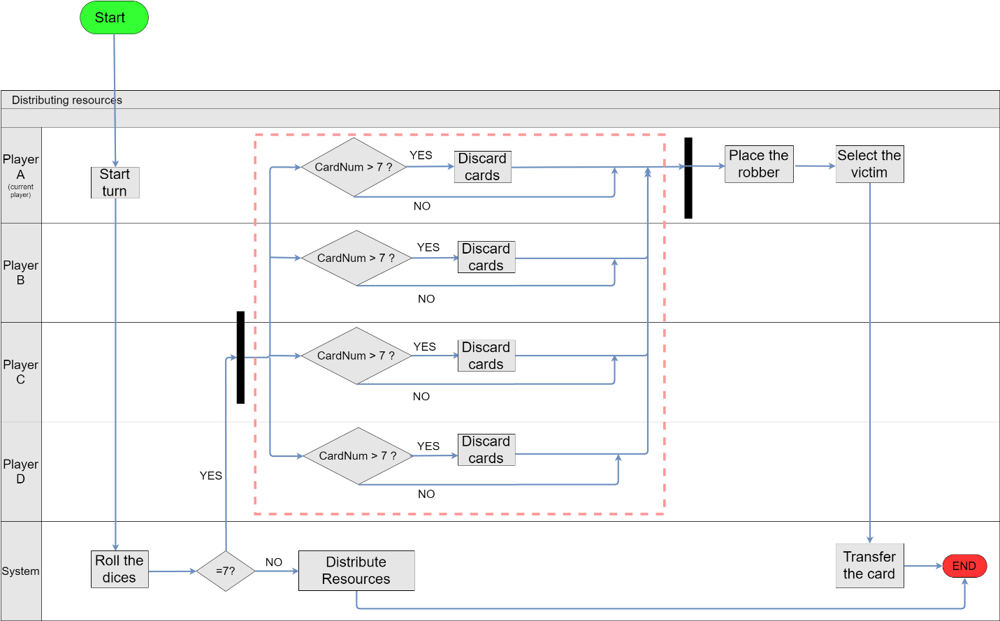

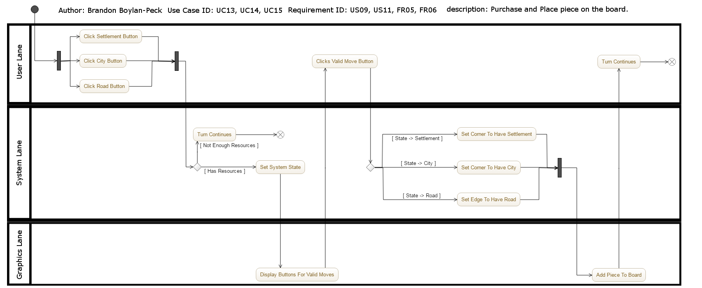

UI Mockups

* Main Menu UI

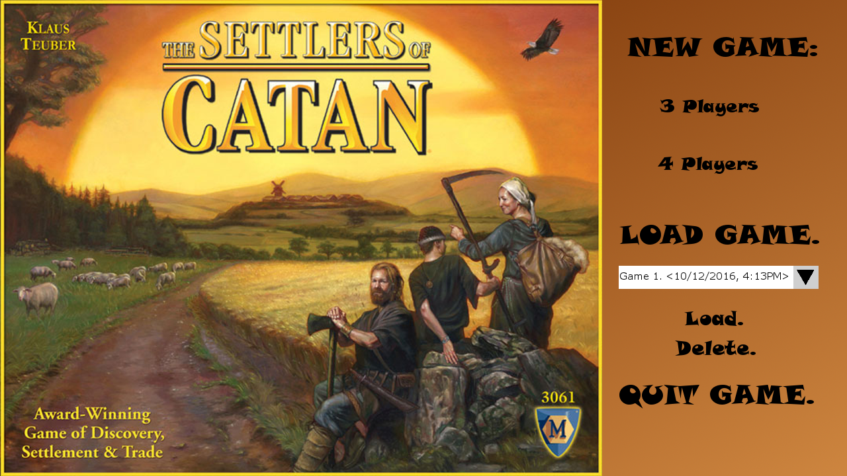

* Game UI

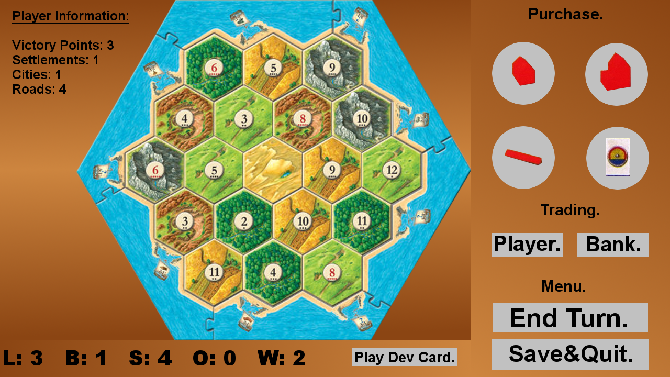

* Trade Player UI

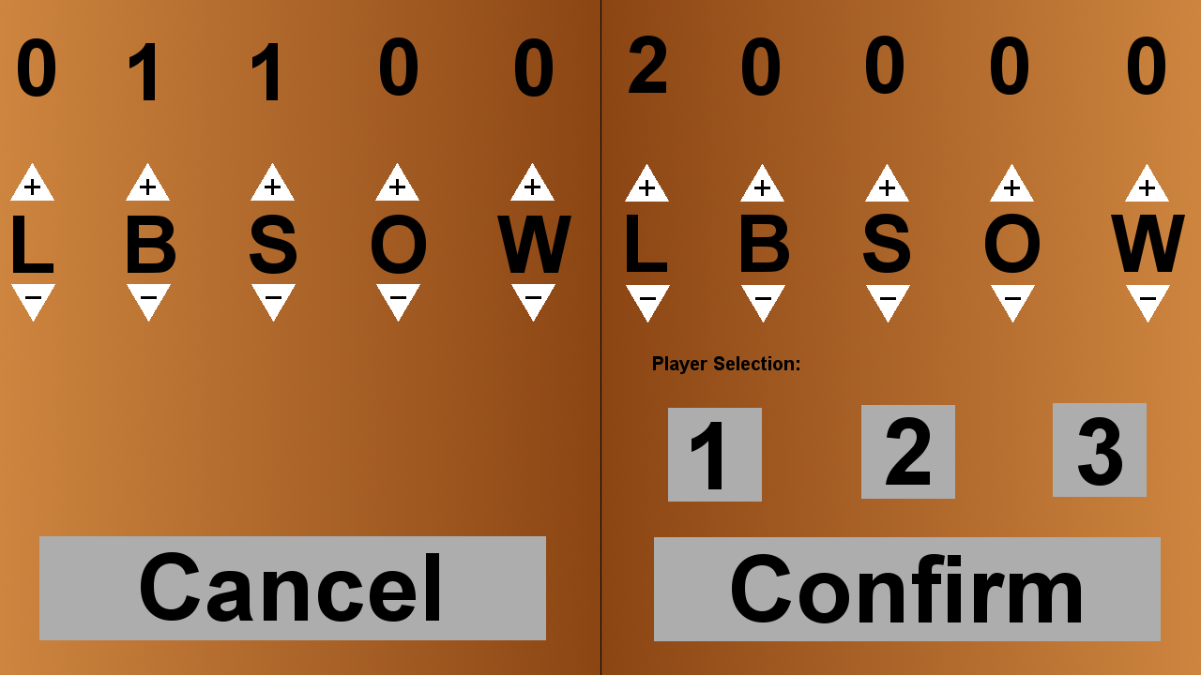

* Trade Bank UI

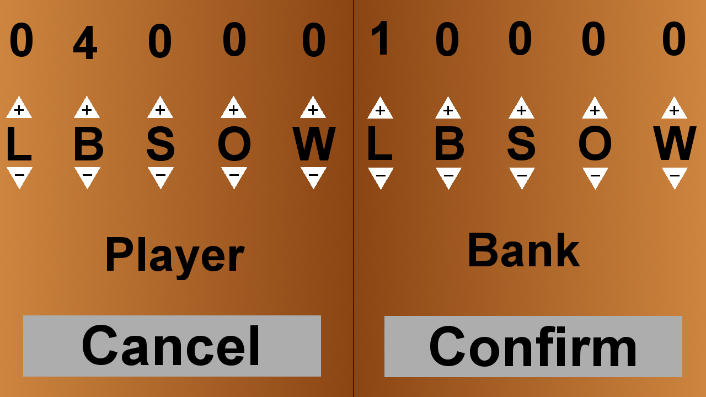

* Steal From UI

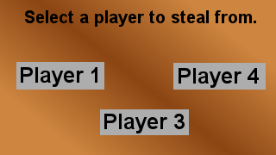

User Interactions

* Author: Chris Hitte
* Description: Setup Initial Pieces
* Project Requirement ID: US-03
* User Case ID: UC\_01



* Author: Yijun Zhang
* Description: (1) placing the robber (2) Distributing resources (2 if-else branches)
* Project Requirement ID: US-05, US-06,FR-03
* User Case ID: UC-04





E:\Genma\Downloads\SequenceDiagram_PurchasePiece (1).png

Class Diagram



Data Usage

Our system will utilize a MySql Database to store all relevant game data. This will facilitate the saving and resuming of games.